React Fiber Architecture

Fiber is a ground-up rewrite of the React's core algorithm(reconciler)
Its headline feature is incremental rendering: the ability to split rendering work into chunks and spread it out over multiple frames.
Other key features include the ability to pause, abort, or reuse work as new updates come in; the ability to assign priority to different types of updates; and new concurrency primitives.

Reconciliation – reconsider what to update & what Not. Recursive Algorithm
The algorithm React uses to diff one tree with another to determine which parts need to be changed.
Actual DOM & Virtual DOM (createRoot)
const root = ReactDOM.createRoot(document.getElementById('root'));

Example- Reconciliation/diffing Algorithm- GitHub

Reconciliation is the algorithm behind what is popularly understood as the "virtual DOM."
A high-level description goes something like this: when you render a React application, a tree of nodes that describes the app is generated and saved in memory. This tree is then flushed to the rendering environment — for example, in the case of a browser application, it's translated to a set of DOM operations. When the app is updated (usually via setState), a new tree is generated. The new tree is diffed with the previous tree to compute which operations are needed to update the rendered app.

What is the Real DOM?
The Real DOM, also known as the actual DOM, is the browser’s representation of a web page’s HTML structure. When a user interacts with a web page, such as clicking a button or filling out a form, the browser updates the Real DOM to reflect the changes. The browser then re-renders the page to display the updated HTML. Costly in terms of performance

What is the Virtual DOM?
The Virtual DOM is an abstraction of the Real DOM, created and maintained by JavaScript libraries such as React. The Virtual DOM is a lightweight copy of the Real DOM, which allows for faster updates and improved performance.
When a user interacts with a web page, React updates the Virtual DOM, compares it with the previous version, and only updates the Real DOM with the necessary changes. This process is known as Reconciliation.
When a user interacts with a web page,
When the app is updated (usually via setState), a new tree is generated. The new tree is diffed with the previous tree to compute which operations are needed to update the rendered app.

https://medium.com/@tanyas022000/redux-vs-context-api-45e5bae61df2

Use React Context API:
1. Small to medium-sized applications
2. Fewer levels of data sharing
3. Component-specific state:

Use Redux:
1. Large and complex applications
2. Deeply nested components
3. Asynchronous data flow

Ultimately, it’s important to assess the specific needs, complexity, and scale of your application to determine whether React Context API or Redux is the most suitable choice for state management. In some cases, a combination of both tools may be appropriate, with React Context API used for local state management and Redux utilized for global state management.

Conclusion
In summary, React Context API is a simpler solution suitable for smaller applications with simple state management needs, while Redux is a more powerful solution suitable for larger and more complex applications with advanced state management needs.

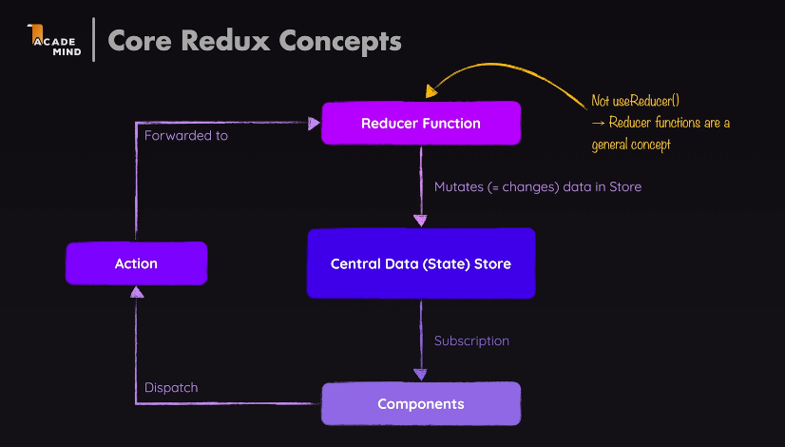
So, components dispatch actions,
which describe what should be done,
but don't do it directly,
then these actions are forwarded to the reducer,
the reducer then does what the action wants, the reducer to do.
And then the reducer, move a new state to central store.
which effectively will replace the existing state in Central Data Store.
And when that state in that data store is updated,
subscribing components are notified,
so that they can update their UI.
That's how Redux works.

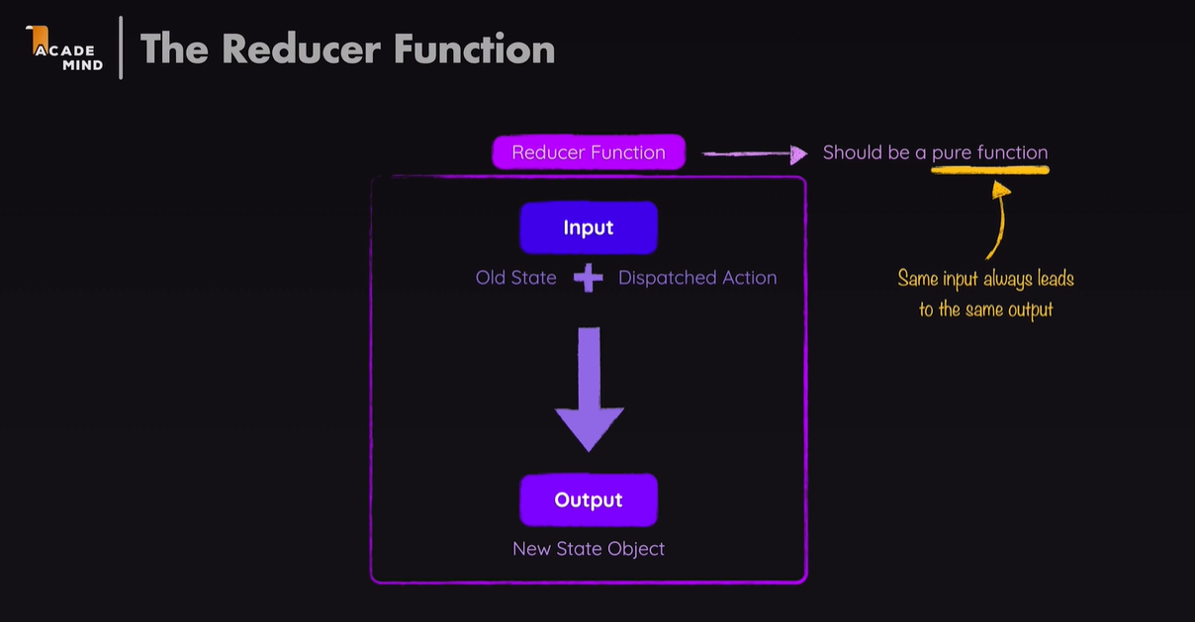
this reducer function will receive the state,
the current state and the action.
It receives that by default
because the reducer will ultimately be executed
by the Redux library.

Now it's this counter reducer,
which we passed to the create store function.
Because the store needs to know which reducer
is responsible for changing that store.
Because keep in mind, it's the reducer
that works together with the store.
So the store wants to know who the reducer function is
that will manipulate the data.

useSelector() - auto subsribe to the redux store. whenever that data changes in the Redux store, it will receive latest data from the redux store
function will be executed by React Redux.
It will then pass the Redux state managed data into function
when it executes it, retrieves the part of the state(returns value)
which then componant use it

useDispatch() - does not accept anything but return dispatch function, we can call this dispatch() function, which will dispatch an action against our Redux store.

Redux state: you should not mutate existing state in redux store, always create new object which will override existing one when it return fro reducer function to store.
issues wuth bigger application - state will gate out of sync, ui wont render right value. cause major problem, bcoz it it hard to troubleshoot.

problem with redux-
typos with action type
in reducer function the new state object we are returning if it is big then we need to create new copy of object and update & return, which will cause duplication
state immutablility

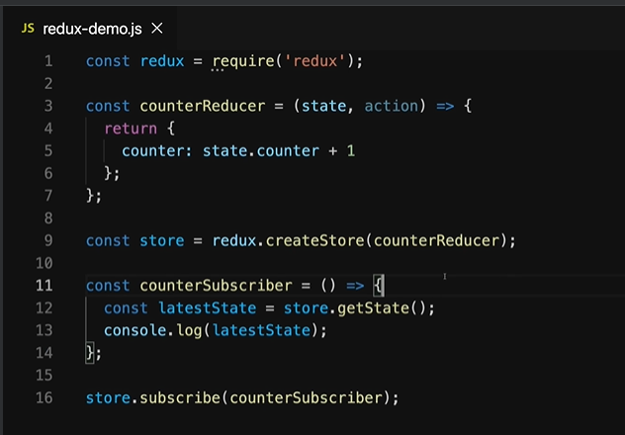
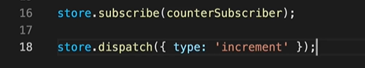
we just point at it just as we did not execute
counter reducer here, but just point at it.
Because both the reducer, as well as the subscriber function
will be executed by Redux.

Add initial state
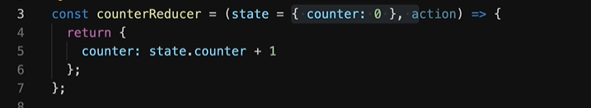
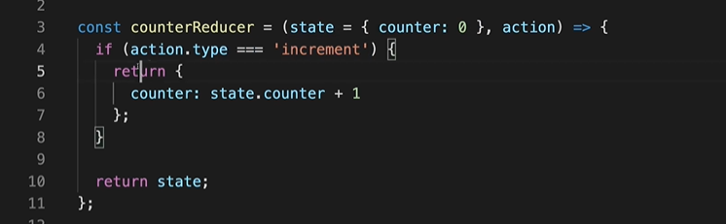
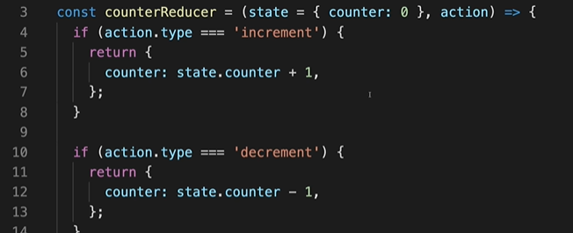
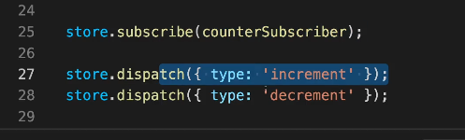

And dispatch is a method which dispatches an action.

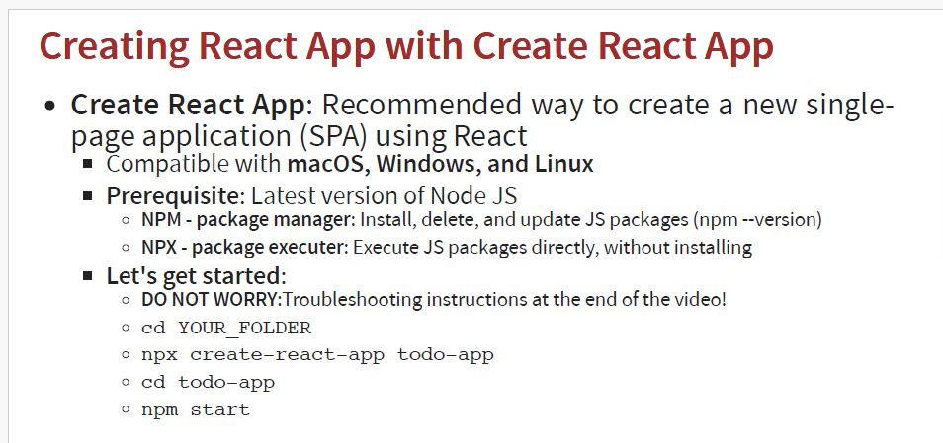
Babel is a very famous transpiler that basically allows us to use future JavaScript in today's browsers.
Eg. Babel is a toolchain that is mainly used to convert ECMAScript 2015+ code into a backwards compatible version of JavaScript in current and older browsers or environments.

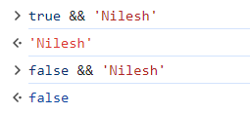
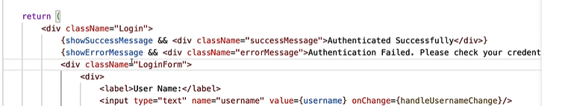

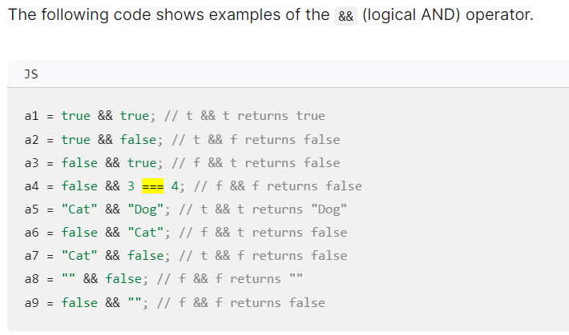

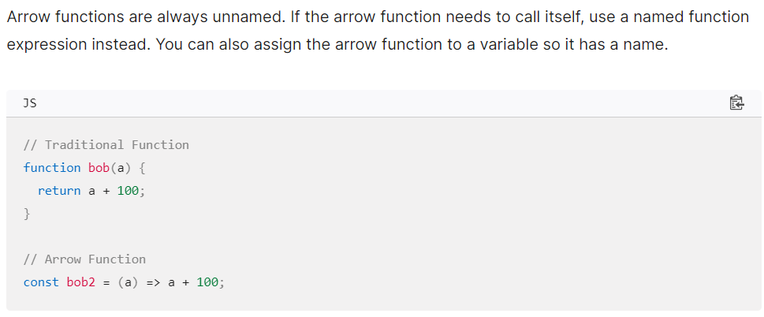
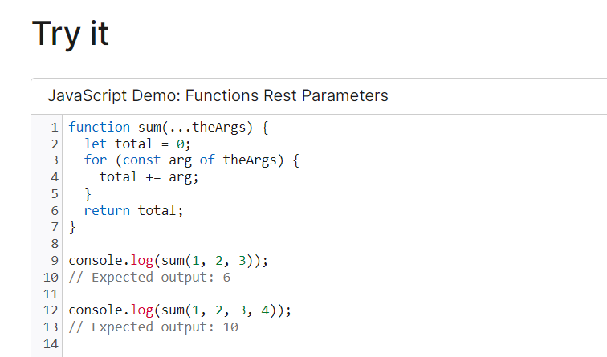
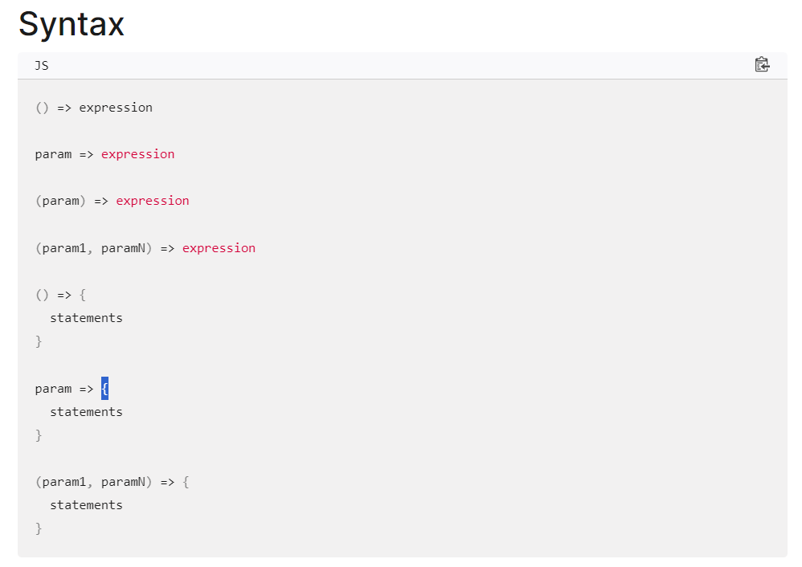

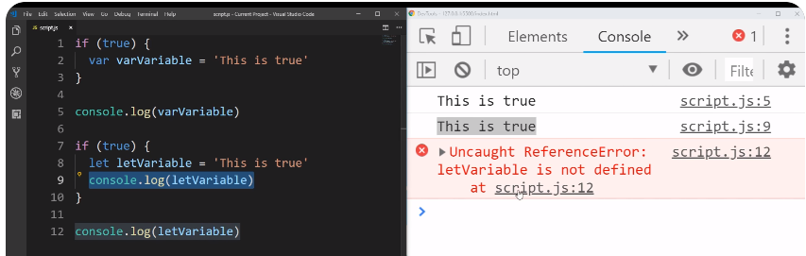
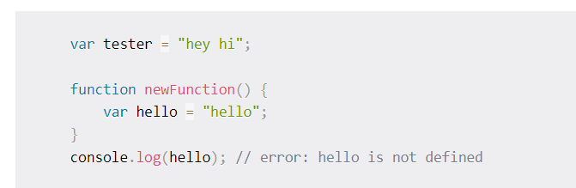
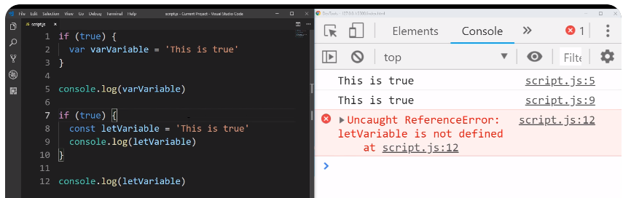
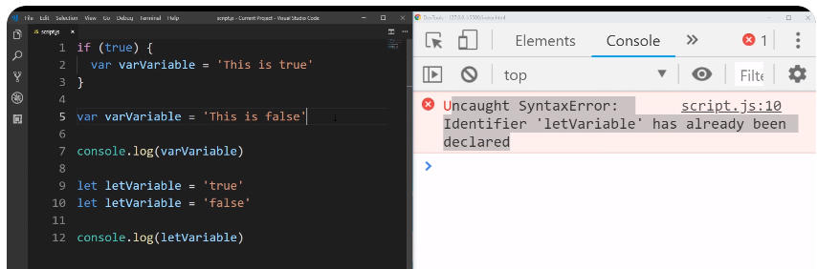
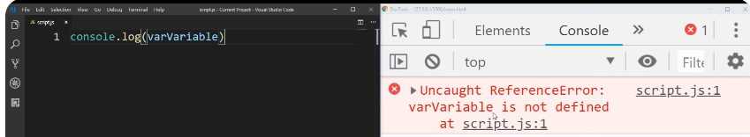
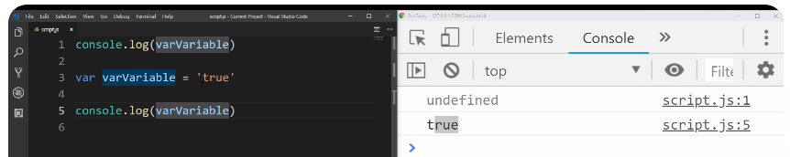
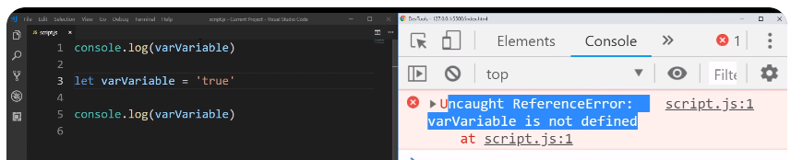
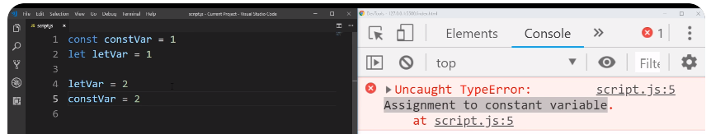
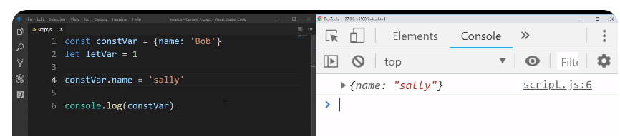
Var is function scoped. Can be re-assigned/re-declare multiple times. Override variable accidently that you dint actually meant to override.
Let & Const is block scoped.

Const does allowed you to change the properties of an object, but does not allow you to assignment to the const operator.

Before the interpreter executes the whole code, it first hoists (raises, or lifts) the declared function to the top of the scope it is defined in.

